**Exploratory Analysis Summary (Focus is on NDP)**

Total number of votes earned by NDP in each of the provinces

1 AB 224800

2 BC 615156

3 MB 81960

4 NB 81105

5 NL 54120

6 NS 85468

7 NT 5783

8 NU 3171

9 ON 1085916

10 PE 14006

11 QC 1075366

12 SK 138574

13 YT 3943

Each row shows the sum of votes for the NDP in that province

The mean absolute deviation of turnout for electoral districts in Ontario province is 5.04084

Table that shows Number of Electoral Districts (Ridings) won by each party (columns) in each province (rows).

BQP CPC GRN LIB NDP

AB 0 29 0 4 1

BC 0 10 1 17 14

MB 0 5 0 7 2

NB 0 0 0 10 0

NL 0 0 0 7 0

NS 0 0 0 11 0

NT 0 0 0 1 0

NU 0 0 0 1 0

ON 0 33 0 80 8

PE 0 0 0 4 0

QC 10 12 0 40 16

SK 0 10 0 1 3

YT 0 0 0 1 0

NDP did not win the highest percentage of ridings in any of the provinces

Bar chart showing the number of Males and Females by which party won the electoral district excluding these territories (Nunavut, Northwest Territories and Yukon)

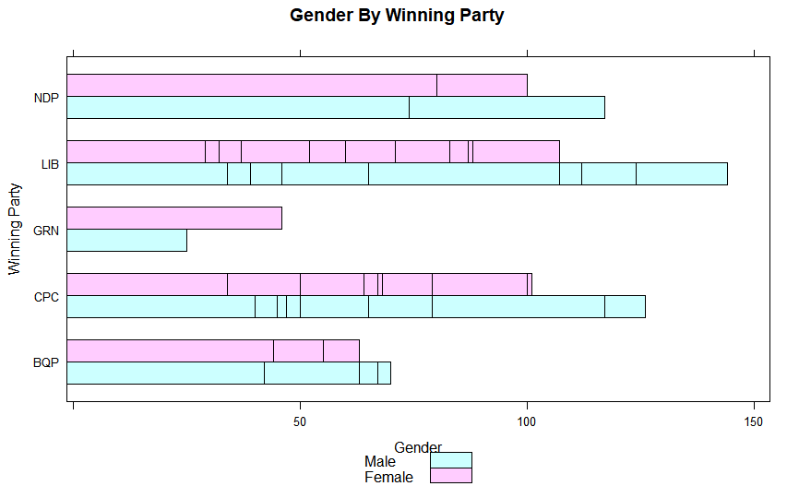

The LIB got the highest number of female voters

Box plot showing the distribution of NDP support across Electoral districts won by each party

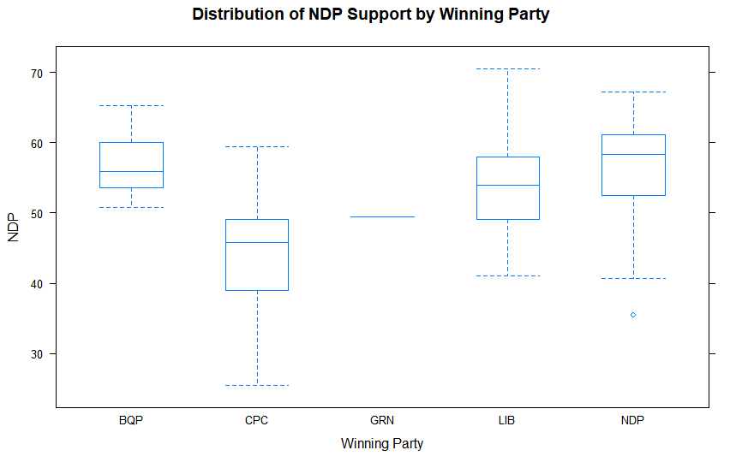

a. NDP has most support in the electoral districts the won represented by the NDP box plot

c. NDP has the least support in districts won by CPC as seen in the second plot (CPC)

d. The electoral districts won by the CPC (CPC Box plot) has the greatest variability of support for the NDP

Scatter plot showing the relationship between NDP and Mulcair

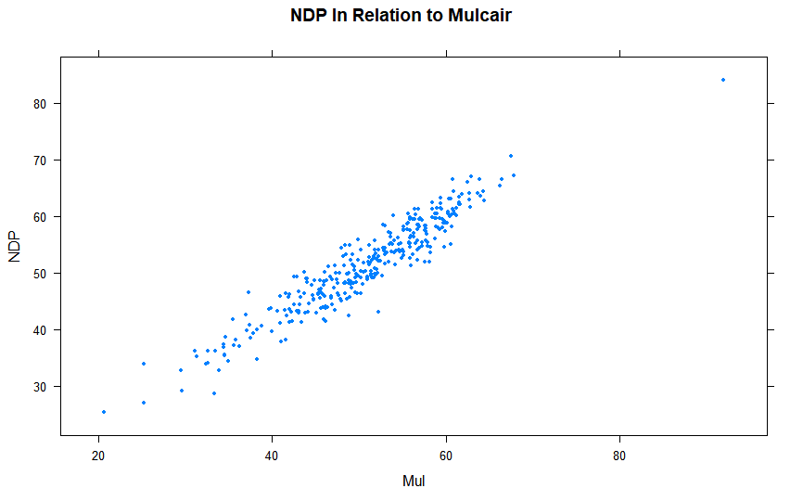

From the chart, there is a strong positive relationship between the party and the leader. As the support for Mulcair increases, the support for the party tend to also increase